**EXERCISE 5:**

**Verify if master is in clean state**

* **git checkout master**
* **git status**

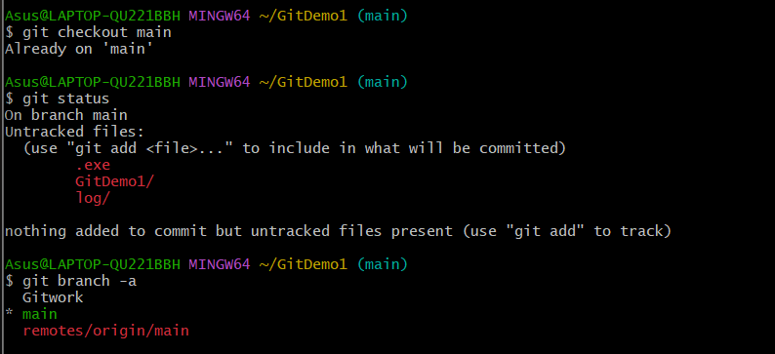

**List all available branches**

* **git branch -a**

**Pull latest changes from remote**

* **git pull origin master**

**Push your local commits to remote**

* **git push origin master**

